MACHINE LEARNING ALGORITHMS

EXERCISE-1

Name – Chethan Kashyap Bangalore Muralidhara

Date – 16-03-2023

Completed Exercises – 1,2,3,4,5,6(All)

Solutions:

1. Code in Python

PS: The entire python(jupyter notebook) code file is also attached.

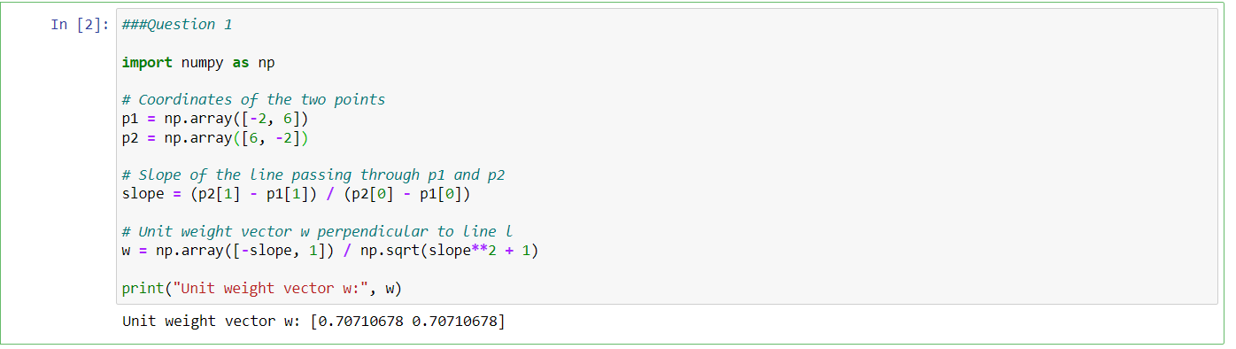

The unit vector is: w = [0.70710678 0.70710678]



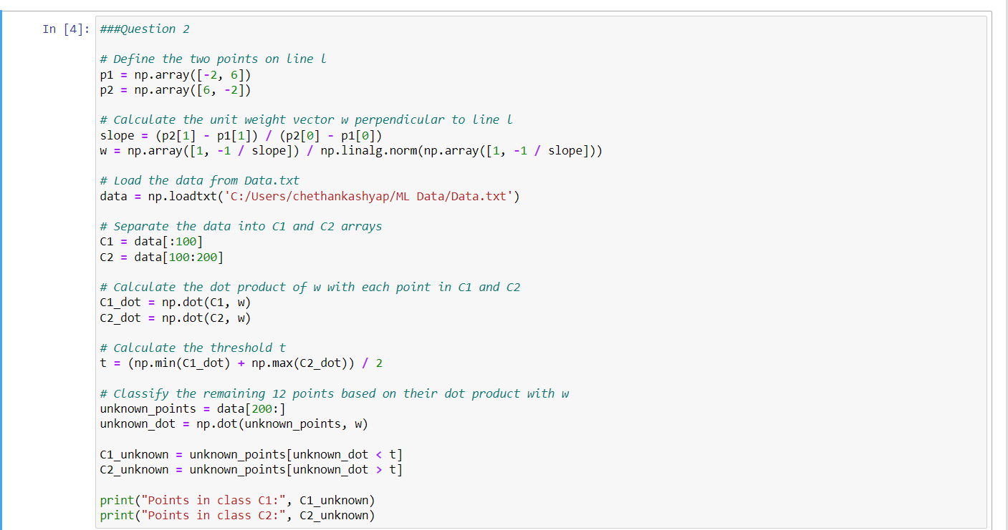

The classified 12 points are:

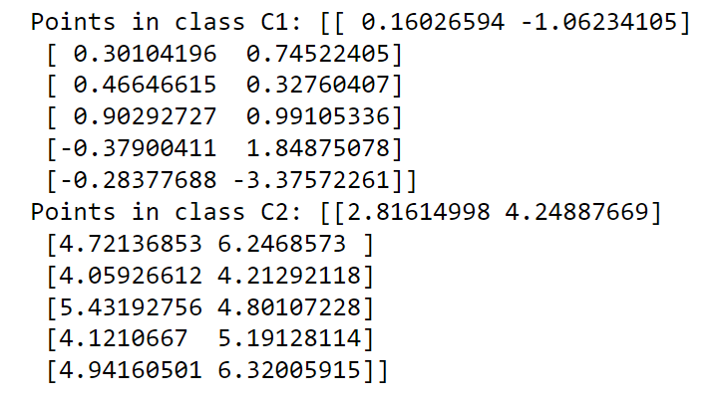



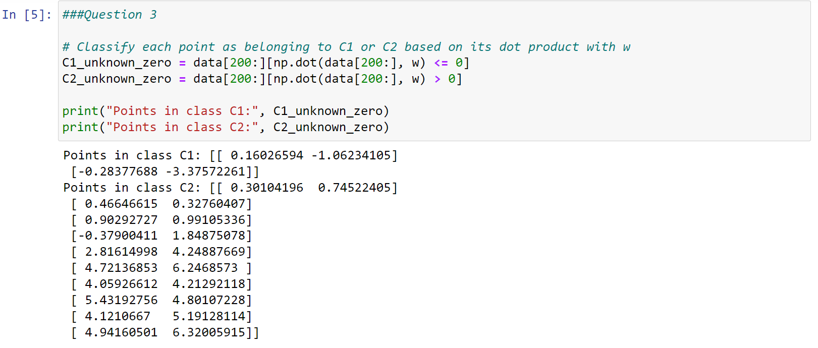



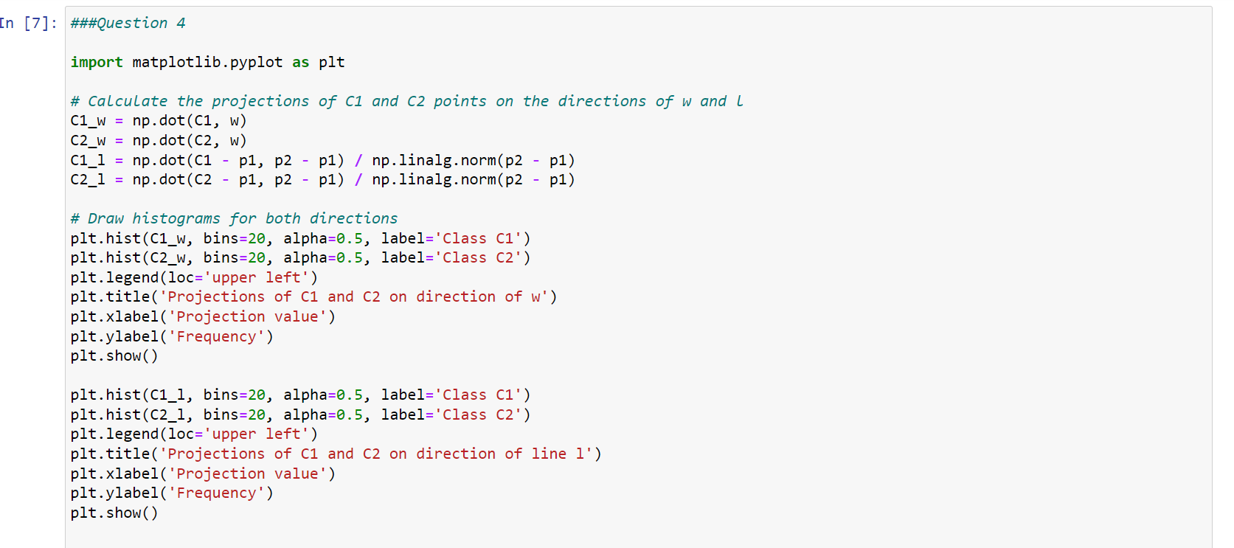

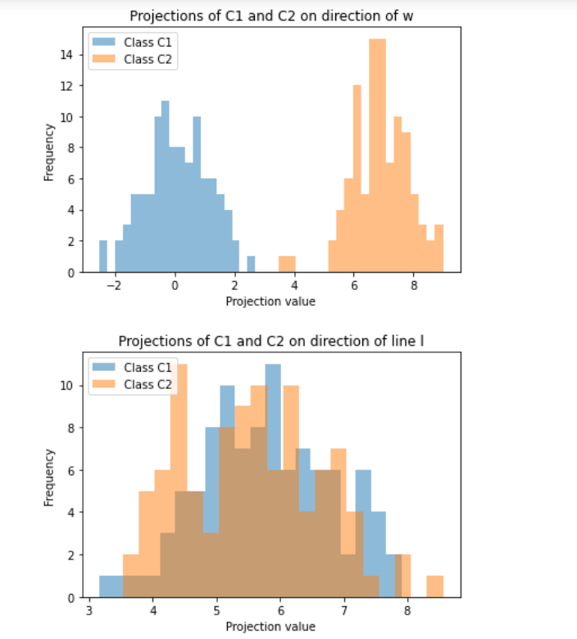

From the graphs, We can interpret these results as follows:

1. For the direction of w, we can see that the projections of C1 and C2 are well separated, with C1 points having higher positive projections and C2

points having higher negative projections. This indicates that w is a good

feature to use for distinguishing between the two classes.

2. For the direction of line l, we can see that there is some overlap

between the projections of C1 and C2, especially in the middle range of

projection values. This suggests that l may not be as effective as w for

distinguishing between the two classes, although there is still some

separation between the two classes at the extremes of the projection range



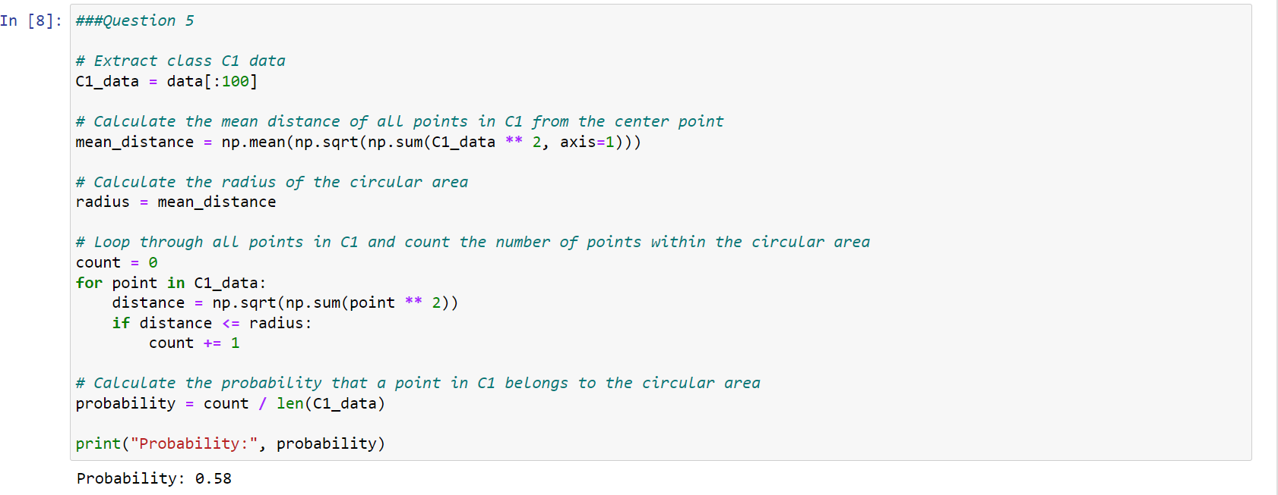

The probability for the event is 0.58.



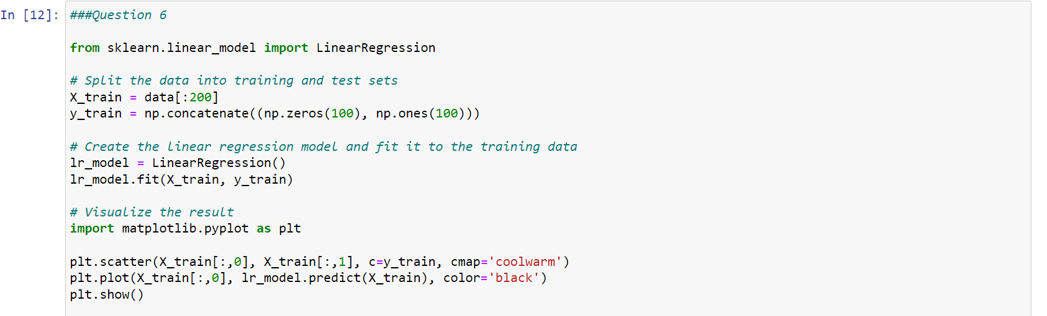

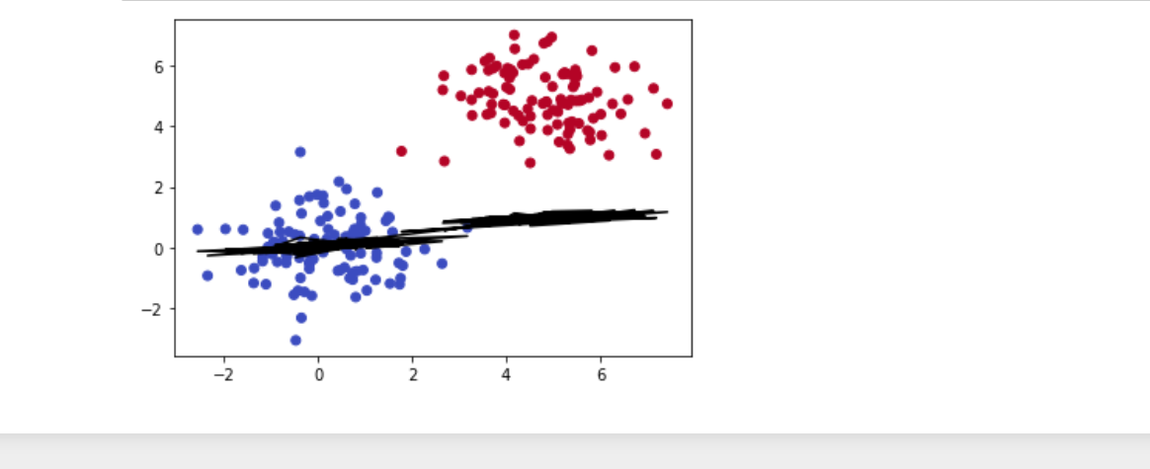

Upon inspection of the plot, we can see that a linear model may not be the best fit for this data as there are many points that do not appear to follow a linear trend. Additionally, there may be issues with overfitting or under fitting if we attempt to use this model on new data.